Missing folders Database :
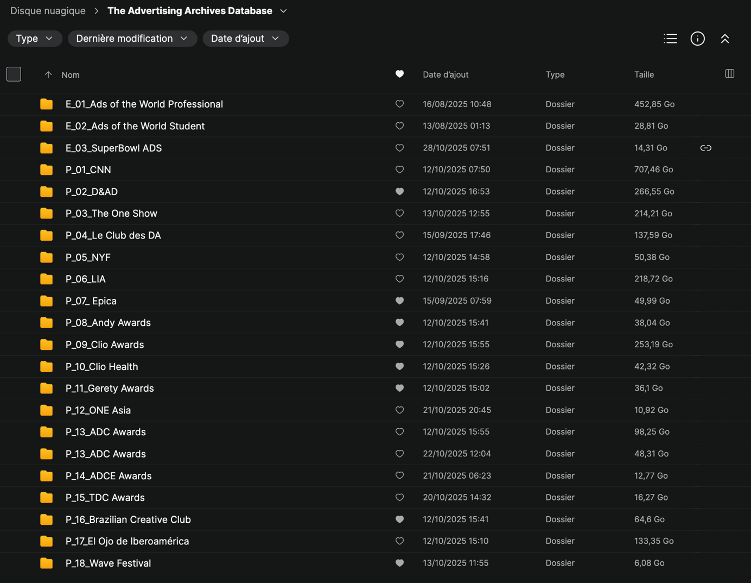

Blue Color = missing files
Green Color = Every files are good
Red Color = rescrap the files

01/
Unblock Coffee Website - CNNS Done

Year 2022 :
https://www.unblock.coffee/cnns/print-publishing/?adsyear=2022

Year 2021 :
https://www.unblock.coffee/cnns/entertainment/?adsyear=2021
https://www.unblock.coffee/cnns/entertainment-for-sport/?adsyear=2021
https://www.unblock.coffee/cnns/radio-audio/?adsyear=2021

Year 2019 :
https://www.unblock.coffee/cnns/print-publishing/?adsyear=2019
https://www.unblock.coffee/cnns/sustainable-development-goals/?adsyear=2019

Year 2018 :
https://www.unblock.coffee/cnns/creative-commerce/?adsyear=2018
https://www.unblock.coffee/cnns/film-craft/?adsyear=2018

Year 2017 :
Missing : https://www.unblock.coffee/cnns/entertainment/?adsyear=2017

Year 2016 :
https://www.unblock.coffee/cnns/direct/?adsyear=2016
https://www.unblock.coffee/cnns/outdoor/?adsyear=2016

02/
Unblock Coffee Website – D&AD OK

03/
Unblock Coffee Website – The OneShow Done

Missing Year 2025
https://www.unblock.coffee/the-one-show/?adsyear=2025

Year 2023 :
https://www.unblock.coffee/the-one-show/direct-marketing/?adsyear=2023

04/
Le club des DA Website – Le club des DA Done
Feedback: The file with the year 2025 is actually 2024, it needs to be rescraped but with the updated date.
https://leclubdesda.org/archives/1?annee=2024

05/
Unblock Coffee Website – New York Festivals Done

Missing Year 2025 :
https://www.unblock.coffee/new-york-festivals/?adsyear=2025

06/
Unblock Coffee Website – London International Awards Done

Missing Year 2025 :
https://www.unblock.coffee/london-international-awards/?adsyear=2025

07/
Epica OK

08/
Unblock Coffee Website – Andy Awards OK

09/
Unblock Coffee Website – Clio Awards OK

10/
Unblock Coffee Website – Clio Health Awards OK

11/
Unblock Coffee Website – Gerety Awards

12/
Unblock Coffee Website – ONE ASIA -

13/
Unblock Coffee Website – ADC

14/
Unblock Coffee Website – ADCE

15/
Unblock Coffee Website – TDC

16/
Unblock Coffee Website – Brazilian Creative Club OK

17/
Unblock Coffee Website – El Ojo de Iberoamérica Awards Done

Missing 2025
https://www.unblock.coffee/el-ojo-de-iberoamerica/?adsyear=2025

18/
Unblock Coffee Website – Wave Festival Awards OK

XX/
https://www.oneclub.org
Regarding the site's database, the majority of the media was not downloaded. For example, in this section: https://www.oneclub.org/awards/theoneshow/-archive/awards/2025/141/all/select, we can see that the folders and projects were indeed created, but there is no media in the files on Mega. I think it must be the same for the other parts of the site, namely the One Asia, ADC, TDC, and ADCE sections. What I suggest is that we rescrape them, but award by award, so I can ensure that the downloads are working correctly.
Answer : Site blocked me from downloading the media due to heavy security on the site.

The databases to be re-downloaded in ORDER :
01/ The One Show :
https://www.oneclub.org/awards/theoneshow/-archive/awards/2025/all/all/select
02/ ADC Awards :
https://www.oneclub.org/awards/adcawards/-archive/awards/2025/all/all/select
03/ TDC Awards Done
https://www.oneclub.org/awards/tdcawards/-archive/awards/2025/all/all/select
04/ ADC Europe Awards
https://www.oneclub.org/awards/adceurope/-archive/awards/2024/all/all/select
05/ ONE Asia Creative Awards Done
https://www.oneclub.org/awards/oneasia/-archive/awards/2024/all/all/select

NEW SCRAPPING
01/
https://lbbonline.com/work?edition=international
80529 Work

Green Files
- Unblock Coffee Website – D&AD OK
- Epica OK
- Unblock Coffee Website – Andy Awards OK
- Unblock Coffee Website – Clio Awards OK
- Unblock Coffee Website – Clio Health Awards OK
- Unblock Coffee Website – Gerety Awards
- Unblock Coffee Website – Brazilian Creative Club OK
- Unblock Coffee Website – Wave Festival Awards OK

RED FILES
- Unblock Coffee Website – ONE ASIA
- Unblock Coffee Website – ADC
- Unblock Coffee Website – ADCE
- Unblock Coffee Website – TDC

